How is the district summary affected?

As both reading and math scores for 9th graders at Thomas High School were replaced with “NaN” the statiscal analysis result in different numbers. Below is a snapshot of the district summary result before and after student data was cleaned.

|  |  |  |  |  |  |  |  |  |
| --- | --- | --- | --- | --- | --- | --- | --- | --- |
| **Before summary** |  |  |  |  |  |  |  |  |
|  | **Total Schools** | **Total Students** | **Total Budget** | **Average Math Score** | **Average Reading Score** | **% Passing Math** | **% Passing Reading** | **% Overall Passing** |
|  | 15 | 39,170 | $24,649,428.00 | 79 | 81.9 | 75 | 86 | 65 |
|  |  |  |  |  |  |  |  |  |
|  |  |  |  |  |  |  |  |  |
| **Current summary** |  |  |  |  |  |  |  |  |
|  | **Total Schools** | **Total Students** | **Total Budget** | **Average Math Score** | **Average Reading Score** | **% Passing Math** | **% Passing Reading** | **% Overall Passing** |
|  | 15 | 39,170 | $24,649,428.00 | 78.9 | 81.9 | 74 | 85 | 64 |

As expected, changes in the math and reading score didn’t make any difference to the total school, total students and total budget. However, average scores, passing scores were changed as the scores for 9th graders from Thomas High School were removed.

How is the school summary affected? How does replacing the ninth graders’ math and reading scores affect Thomas High School’s performance, relative to the other schools?

As scores were removed only for one grade in one school, overall school performance didn’t change much.

However, it has greatly affected the overall passing percentage of the Thomas High School.

Below are the table capturing the school summary before and after the scores were cleaned for the Thomas High School. Data for the Thomas High School is shaded with blue in both tables.

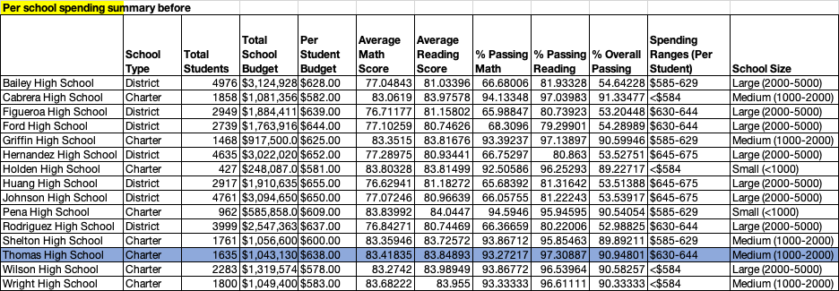



How does replacing the ninth-grade scores affect the Math and Reading Scores by Grade, Scores by School Spending, Scores by School Size, and Scores by School Type?